Operational Concept Description (OCD)

City of Los Angeles Personnel Department Mobile Applications

Team 02

ANUSHREE SRIDHAR - Software Architect

SHREYA KAMANI - Project Manager

DIVYA REDDY - Requirements Engineer

PATTRA THONGPRASERT - Operation Concept Engineer

ABHISHEK TRIGUNAYAT - Prototyper

TRAVIS JONES - Feasibility Analyst

WILLIAM EVERTON - IIV and V

Image7.png

USC-CSSE

# Version History

| Date | Author | Version | Changes made | Rationale |
| --- | --- | --- | --- | --- |
| 09/25/13 | Abhishek, Pattra | 1.0 | * Initial version * Add shared vision * Complete section 1, 2, and 3.1 | * First version of document created for Team 02 project |
| 10/12/13 | Abhishek,Pattra | 1.1 | * Update shared vision * Add new proposed system information * Complete all sections * Update format and template | * Make corrections based on IIV&V comments * Continued operational concept design for foundation phase |
| 10/23/13 | Abhishek,Pattra | 1.2 | * Update shared vision * Update goals | * Make correction according to ARB comments |
| 10/31/13 | William | 1.3 | * Reviewed and verified content * Revised formatting for consistency | * Revised for consistency according to retrospective analysis |

# Table of Contents

Version History ii

Table of Contents iii

Table of Tables iv

Table of Figures v

1 Introduction 1

1.1 Purpose of the OCD 1

1.2 Status of the OCD 1

2 Shared Vision 2

2.1 Overview of the system 2

2.2 Benefit Chain 3

2.3 System Boundary and Environment 4

3 System Transformation 5

3.1 Information on Current System 5

3.1.1 Infrastructure 5

3.1.2 Artifacts 5

3.1.3 Current Business Workflow 6

4 System Objectives, Constraints and Priorities 7

4.1 Capability Goals 7

4.2 Level of Service Goals 7

4.3 Organizational Goals 7

4.4 Constraints 7

4.5 Relation to Current System 8

5 Proposed New Operational Concept 9

5.1 Element Relationship Diagram 9

6 Organizational and Operational Implications 11

6.1 Organizational Transformations 11

6.2 Operational Transformations 11

# Table of Tables

**Table 1: The Program Model 2**

**Table 2: Current System Infrastructure 5**

**Table 3: Current System Artifacts 5**

**Table 4: Capability Goals 7**

**Table 5: Level of Service Goals 7**

**Table 6: Relation to Current System 8**

# Table of Figures

**Figure 1 - Benefit Chain Diagram 3**

**Figure 2 - System Boundary and Environment Diagram 4**

**Figure 4: Current Business Workflow Diagram 6**

**Figure 5: Element Relationship Diagram of City of LA Personnel Department Mobile Application 9**

**Figure 6: Proposed System Business Workflow Diagram 10**

# 1 Introduction

## 1.1 Purpose of the OCD

This document provides, in detail, the shared visions and goals of the stakeholders of the Mobile Application development project for the Los Angeles Personnel Department. The success-critical stakeholders of the project are Leo Reyes, Senior Personnel Analyst of the City of Los Angeles Personnel Department; City of Los Angeles Personnel Department IT staffs as maintainer; NeoGov as the jobs information provider; the job seekers as the users of the system; and Team 2 members as developers.

## 1.2 Status of the OCD

This OCD report is version 1.2, the continuity of the previous version with correction based on the ARB comments, and is in the Valuation phase. The development team has updated the scope of the key stakeholders’ shared vision, current system, new proposed system, goals and constraints, and organizational and operational implications.

# 2 Shared Vision

## 2.1 Overview of the system

Table 1: The Program Model

|  |  |  |  |
| --- | --- | --- | --- |
| **Assumptions**   1. Job seeker will prefer a mobile application for searching for jobs at City of LA. 2. Mobile application provides added value to city of LA better than website 3. Having a mobile application will attract more candidates. | | | |
| **Stakeholders** | **Initiatives** | **Value Propositions** | **Beneficiaries** |
| * Developers * Personnel department selection division * Personnel department IT division (System administrator) * Information Technology Agency (ITA) * NeoGov (streamlining application provider) * Job seekers * Current employees looking for promotion | * Develop the system * Promote the application * Train about maintenance (post deployment) * Send notifications to the job seekers * Subscribe to receive notifications | * Provide easy access for job seekers * Attract qualified candidates to the city department * Better outreach for job seekers * Improve brand image of Los Angeles Personnel Department * Streamlining recruiting process | * Job seekers * Current employees for looking promotion * Personnel department selection division |
| **Costs** | | **Benefits** | |
| * Development cost * Maintenance cost * Infrastructure cost * Training cost | * Transition cost * Mitigation cost * Operation cost | * Increase time efficiency through the procurement of more qualified professionals | |

#### 

## 2.2 Benefit Chain

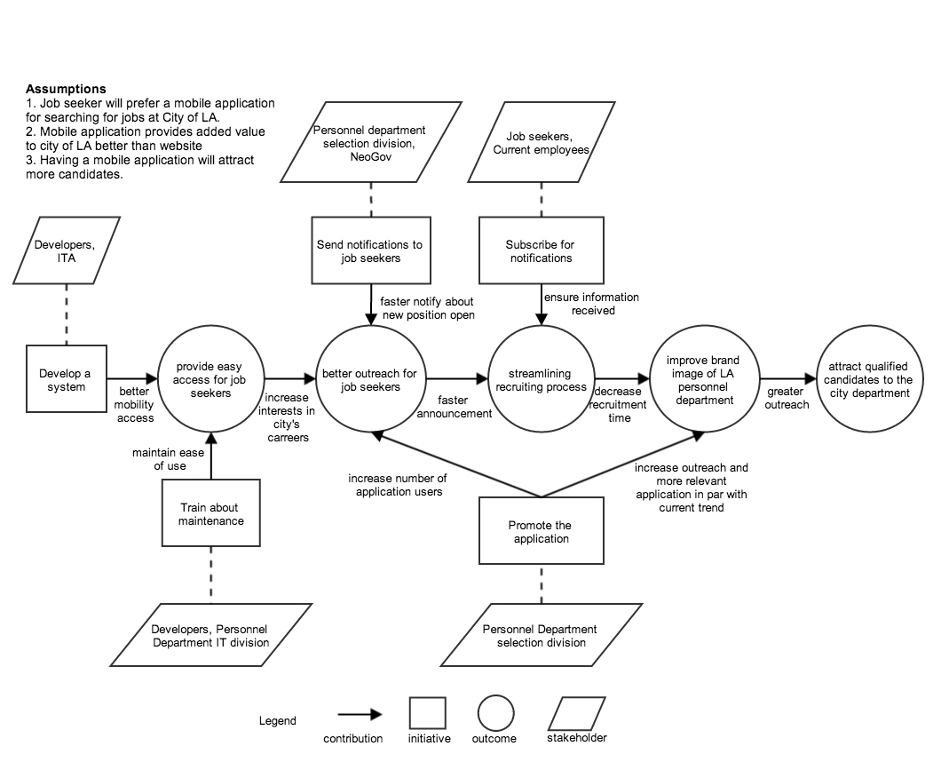Figure - Benefit Chain Diagram

## 2.3 System Boundary and Environment

Figure - System Boundary and Environment Diagram

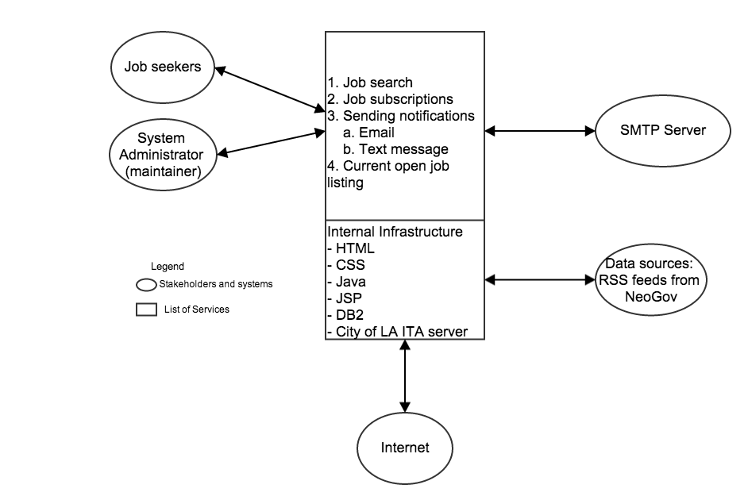

# 3 System Transformation

## 3.1 Information on Current System

### 3.1.1 Infrastructure

Table 2: Current System Infrastructure

|  |  |
| --- | --- |
| **Infrastructure** | **Details** |
| Hardware | Microsoft Windows and Mac OS computers, LA ITA Servers |
| Software | Adobe ColdFusion |
| Database | DB2 |
| Development language | Adobe ColdFusion |

### 3.1.2 Artifacts

Table 3: Current System Artifacts

|  |  |
| --- | --- |
| **Artifact** | **Description** |
| Opening jobs form | Form for entering information about new opening job position on Neogov website |
| RSS feed | Feed of opening job positions send from Neogov’s system to personnel department website |
| Application form | Form that job seekers fill their information for applying a position |
| Examination information | Information of the exam that job applicant need to take to apply for the position |
| All job positions information | Listing of all the job positions with details in City of Los Angeles |
| Opening job information | Listing of all the job opening with details |

### 3.1.3 Current Business Workflow

Figure : Current Business Workflow Diagram

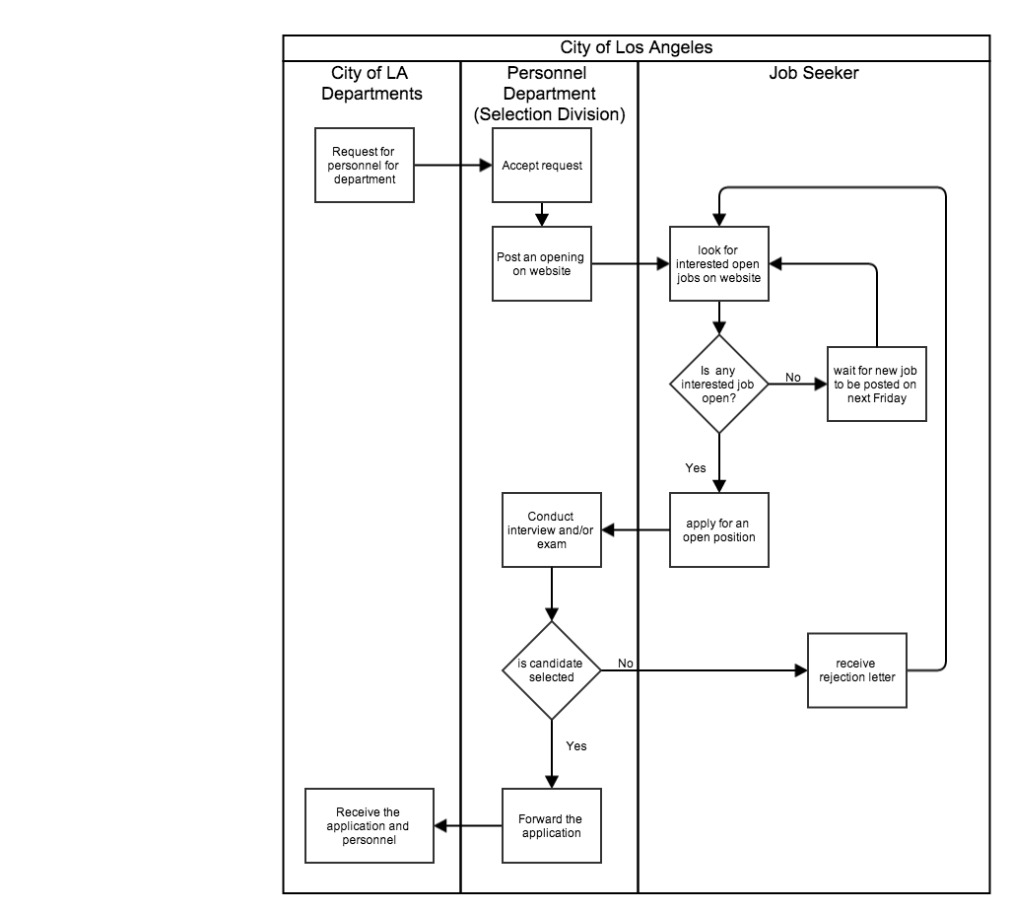

# 4 System Objectives, Constraints and Priorities

## 4.1 Capability Goals

Table 4: Capability Goals

|  |  |
| --- | --- |
| **Capability Goals** | **Priority Level** |
| **OC-1: List jobs** – job seekers can view all job positions and current open positions with details | Must have |
| **OC-2**: **Send notifications** – the system will send notifications via text message or email to potential job seekers who subscribe for the notification | Must have |
| **OC-3**: **Subscription to jobs** – job seekers can subscribe to receive notification for jobs they find interesting | Must have |

## 4.2 Level of Service Goals

Table 5: Level of Service Goals

|  |  |  |
| --- | --- | --- |
| **Level of Service Goals** | **Priority Level** | **Referred Win-Win Agreements** |
| **LOS-1: System down time** - the downtime of the system cannot be longer than 2 hours a day | N/A  The server will be under ITA responsibility | Win Condition (WC_2386):  System downtime at most 2 hours a day |

## 4.3 Organizational Goals

**OG-1**: Provide easy access for job seekers

**OG-2**: Better outreach for job seekers

**OG-3**: Improved brand image of Los Angeles Personnel Department

**OG-4**: Attracted qualified candidates to city department

**OG-5**: Streamlining recruiting process

## 4.4 Constraints

**CO-1:** System shall be developed for Android and iPhone

**CO-2:** DB2 database will be used

**CO-3:** PHP will not be used for development

**CO-4:** Preferred language: Cold fusion, ASP, Java

## 4.5 Relation to Current System

Table 6: Relation to Current System

|  |  |  |
| --- | --- | --- |
| **Capabilities** | **Current System** | **New System** |
| Roles and Responsibilities | * Maintainer or System administrator update current job information on website * Job seekers obtain job information from the website | * Maintainer or System administrator update current job information on website * Job seekers obtain job information from the mobile devices |
| User Interactions | Job seekers periodically check for open jobs on the website | Job seekers can subscribe and receive notification for open jobs via their Android and iOS mobile devices |
| Infrastructure | Hardware: City of LA ITA servers  Software: Adobe ColdFusion  Database: DB2  Development language: Adobe ColdFusion | Hardware: City of LA ITA servers, Android and iOS mobile devices  Software: Eclipse, Xcode, Sublime, Notepad++  Database: DB2  Development language: CSS, HTML, Java, JSP, PhoneGap API |
| Stakeholder Essentials and Amenities | Personnel department Selection division  Personnel department IT division  Information Technology Agency (ITA)  Neogov’s website and RSS feeds  Maintainer or System administrator | Developers  Personnel department Selection division  Personnel department IT division  Information Technology Agency (ITA)  Neogov’s website and RSS feeds  Maintainer or System administrator |
| Future Capabilities | Not defined | Not defined |

# 5 Proposed New Operational Concept

## 5.1 Element Relationship Diagram

Figure : Element Relationship Diagram of City of LA Personnel Department Mobile Application

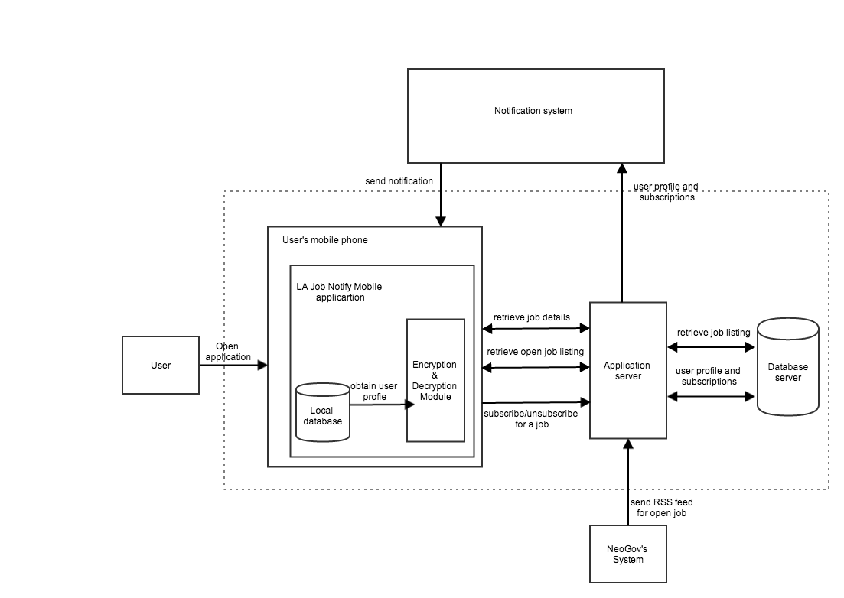

##### 5.2 Business Workflows

Figure : Proposed System Business Workflow Diagram

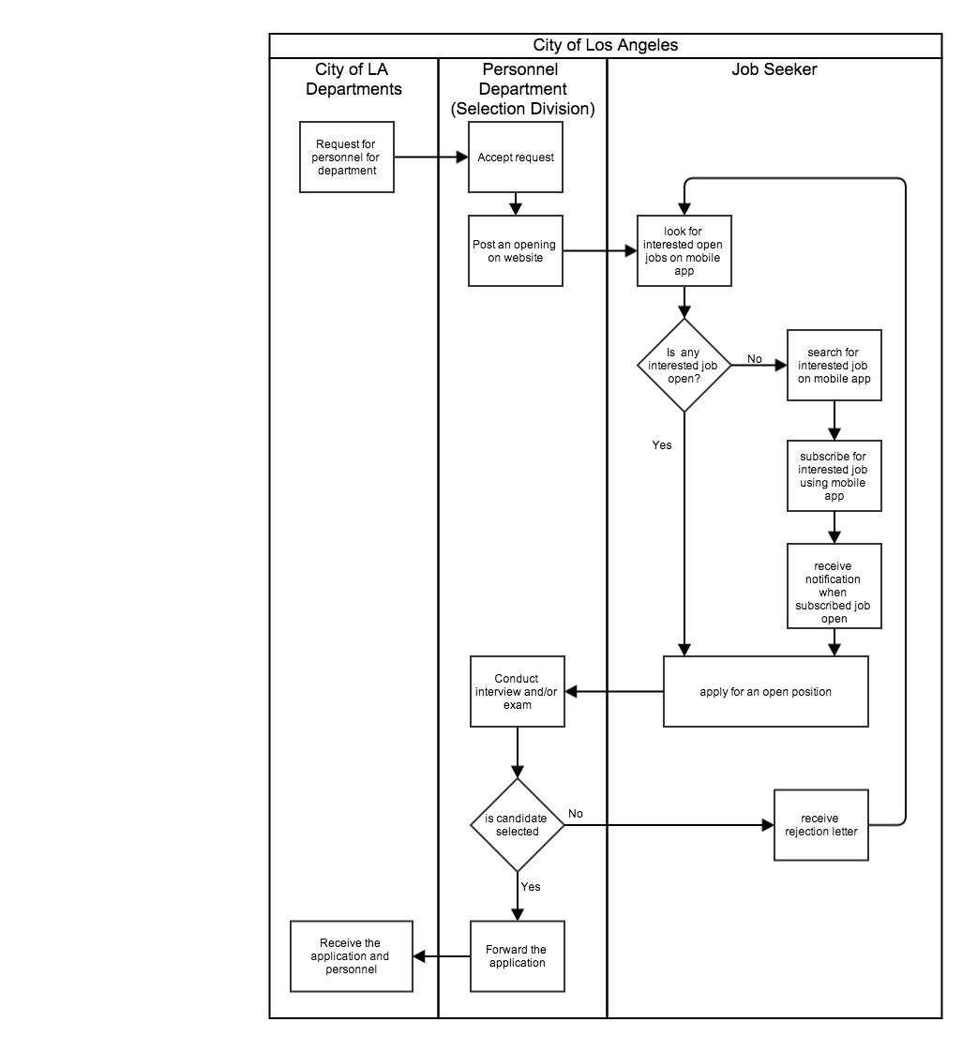

# 6 Organizational and Operational Implications

## 6.1 Organizational Transformations

The significant changes in organizational structure, authority, roles, and responsibilities that will result from transitioning to the new system including:

* The need to appoint existing staff or hire a new system maintainer to take care of the mobile application on both platform (Android and iOS) and the back-end system
* Personnel Department is expected to receive higher number of applications in shorter period because of the greater outreach

## 6.2 Operational Transformations

The significant changes in operational procedures and workflows that will result from transitioning to the new system including:

* The option for job seekers to access the City of LA job information via website and/or mobile application
* Users (job seekers) do not need to access the website to check for opening positions periodically because after subscribing for a job, users will be notified via email and/or text message when the position available.